Brightloop SMS — System Architecture
Oct 31, 2026 · @Mohamed

Overview
We are building one Django web app that runs Brightloop Software's whole subscription business: products and plans, quotations, subscriptions, recurring invoices, discounts, payments and finance reporting, for three roles (Admin, Internal Staff, Customer).
It is a single business (Brightloop), not a multi-company SaaS platform. Built by a team of 4 in 8 hours, with every member pushing to main every hour.
Design principles
- One monolith, one database. One Django project, six apps, one SQLite file. No separate frontend or API server to integrate.
- Business rules live on the server. Validation, permissions, state changes and money calculations happen in Django, never only in the browser.
- Money is exact. Every amount is DecimalField with 2 decimal places. No floats anywhere.
- Billing is safe to repeat. Running billing twice never creates a second invoice for the same period.
- Invoices are frozen. An invoice copies its lines at billing time, so later price changes never alter old invoices.
- Each member owns a vertical slice. Models, views, forms and templates of one app belong to one person.
Tech stack
Layer | Choice | Why
Language | Python 3.11+ | Team's strongest language
Web framework | Django 5 | Built-in auth, password reset, ORM, forms, admin, CSRF protection
Database | SQLite (local file) | Zero setup, works offline; swappable to PostgreSQL by changing DATABASES
Pages | Django templates | Server-rendered HTML, no separate frontend build
Styling | Bootstrap 5 | Responsive, consistent look without custom CSS work
Charts | Chart.js | Revenue and status charts on the dashboard
Date maths | python-dateutil (relativedelta) | Correct month and year steps (Jan 31 → Feb 28)
Email | Django console email backend | Password reset links work offline, printed in the terminal
Printing | Print-friendly invoice page + browser print to PDF | No PDF library needed
Version control | Git + GitHub, hourly pushes to main | Required by judges; everyone commits

High-level architecture
The whole system is one Django process between the browser and one SQLite file; there is no separate frontend or API server.
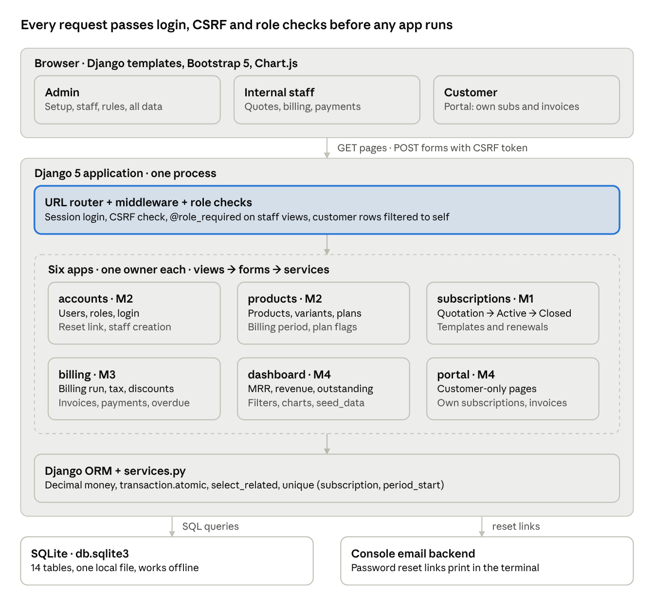
System architecture · 3 roles, 6 apps, 1 database
Lifecycle of one request (example: staff clicks Run billing)
- Browser sends POST /billing/run/ with the session cookie and CSRF token.
- Middleware loads the logged-in user and rejects the request if the CSRF token is missing.
- The URL router hands it to billing.views.run_billing_view, whose @role_required('admin', 'staff') rejects customers.
- The view calls billing.services.run_billing(today), which reads and writes through the ORM inside transactions.
- The view adds a message ("Created 37 invoices, skipped 3") and redirects to the invoice list; the browser loads the new page with a GET.

Django apps and ownership
The project has six apps. Each app has one owner who writes its models, forms, views, URLs and templates. Dependencies only point downward in this table: billing may import from subscriptions, never the other way round.
App | Owner | Responsibility | Depends on
accounts | M2 (CS) | Custom User with role, register, login, logout, password reset, admin-only staff creation, role decorators, password validator | —
products | M2 (CS) | Product, Variant, Plan (billing period, minimum quantity, availability dates, close/pause/renew flags) | accounts
subscriptions | M1 (Jee) | Subscription, SubscriptionLine, QuotationTemplate, TemplateLine; numbering; state transitions; pause, renew, close, auto-close | accounts, products
billing | M3 (DS) | TaxRule, Discount, Invoice, InvoiceLine, Payment; billing run; discount and tax engine; invoice actions; payments | subscriptions, products
dashboard | M4 | Finance metrics, filters, overdue list, charts; seed_data management command | all of the above (read only)
portal | M4 | Customer-only pages: my subscriptions, my invoices, invoice detail and print | subscriptions, billing (read only)
Shared files and their owners
File | Owner | Rule for everyone else
config/settings.py | M2 | Ask M2 to add your app to INSTALLED_APPS
config/urls.py | M2 | You may add exactly one include() line for your app
templates/base.html, static/ | M4 | Extend base.html; ask M4 for navigation changes
README.md | M1 | Send M1 one line describing your module
Where logic goes inside an app
- models.py: fields, constraints, indexes, simple properties (e.g. balance_due).
- services.py: business rules that change data (billing run, state transitions, applying discounts). Views call services; services never touch request.
- forms.py: input validation for every form.
- views.py: permission check → form → service → redirect with a message.
- templates/<app>/: pages extending base.html.

Roles and access control
Every view checks the role on the server; hiding a menu item is never the protection. A customer sees only their own records, and a request for anyone else's record returns 404 (not 403, so it doesn't reveal the record exists).
Action | Admin | Staff | Customer
Create staff accounts | Yes | No | No
Products, variants, plans, tax rules | Create, edit | View | No
Discount rules | Create, edit | View, apply | No
Quotation templates | Create, edit | Use | No
Customers | Create, edit | Create, edit | Own profile
Subscriptions | All actions | Create, move through states | View own
Run billing | Yes | Yes | No
Invoices: confirm, cancel, send, print | Yes | Yes | View and print own
Record payments | Yes | Yes | No
Finance dashboard | Yes | Yes | No
How it is enforced
- User.role is one of admin, staff, customer. New sign-ups are always customer; the role field never appears on the public sign-up form.
- accounts/decorators.py provides @role_required('admin') and @role_required('admin', 'staff'). Every staff-side view uses one.
- Customer pages in portal always filter by the logged-in user, e.g. get_object_or_404(Invoice, pk=pk, subscription__customer=request.user).
- After login, users are sent to their home: Admin and Staff to the dashboard, Customer to the portal.
- The Django admin panel (/django-admin/) is for the team's own debugging only, not part of the demo.

Data model
The app has 14 models. All money fields are DecimalField(max_digits=12, decimal_places=2); all models have created_at and updated_at. A quotation is not a separate table: it is a Subscription in the Quotation state.
Model (app) | Key fields | Relations | Constraints and indexes
User (accounts) | email (login), name, role, company, phone, address, is_active | — | email unique (case-insensitive); index on role
Product (products) | name, product_type, sales_price, cost_price, notes, is_active | → TaxRule (default tax) | sales_price ≥ 0, cost_price ≥ 0
ProductVariant (products) | attribute (e.g. Brand), value (e.g. Odoo), extra_price | → Product | unique (product, attribute, value)
Plan (products) | name, price, billing_period (daily/weekly/monthly/yearly), min_quantity, start_date, end_date, auto_close, closable, pausable, renewable | → Product (optional) | min_quantity ≥ 1; end_date > start_date
QuotationTemplate (subscriptions) | name, validity_days, payment_terms_days | → Plan | validity_days ≥ 1
TemplateLine (subscriptions) | quantity, unit_price | → QuotationTemplate, → Product, → ProductVariant (optional) | quantity ≥ 1
Subscription (subscriptions) | number (SUB-0001), status, start_date, expiry_date, next_billing_date, billed_cycles, quotation_valid_until, payment_terms_days | → User (customer), → Plan, → QuotationTemplate (optional) | number unique; index on (status, next_billing_date); index on customer
SubscriptionLine (subscriptions) | quantity, unit_price, amount | → Subscription, → Product, → ProductVariant (optional), → TaxRule | quantity ≥ plan.min_quantity
TaxRule (billing) | name (e.g. GST 18%), rate (percent), is_active | — | 0 ≤ rate ≤ 100
Discount (billing) | name, kind (fixed/percent), value, min_purchase, min_quantity, start_date, end_date, usage_limit, times_used, is_active | ↔ Product (many-to-many, optional), ↔ Subscription (many-to-many, optional) | percent value ≤ 100; times_used ≤ usage_limit
Invoice (billing) | number (INV-0001), status, period_start, period_end, invoice_date, due_date, subtotal, discount_total, tax_total, total, amount_paid, sent_at | → Subscription | number unique; unique (subscription, period_start); index on (status, due_date)
InvoiceLine (billing) | product_name, variant_name, quantity, unit_price, discount_amount, tax_rate, tax_amount, line_total (all copied at billing time) | → Invoice | —
DiscountUse (billing) | amount | → Discount, → Invoice | unique (discount, invoice)
Payment (billing) | method (cash/card/bank transfer/UPI), amount, payment_date, note | → Invoice, → User (recorded_by) | amount > 0; amount ≤ invoice balance
Computed, not stored
- Invoice.balance_due = total − amount_paid.
- Invoice.is_overdue = status is Confirmed and due_date < today and balance_due > 0. Stored as a query filter, not a status, so it is always current.
- Subscription.monthly_value = sum of line amounts converted to a monthly rate (used for MRR).

State machines
Status changes happen only through service functions (subscriptions/services.py, billing/services.py) that check the current state first; views never set status directly.
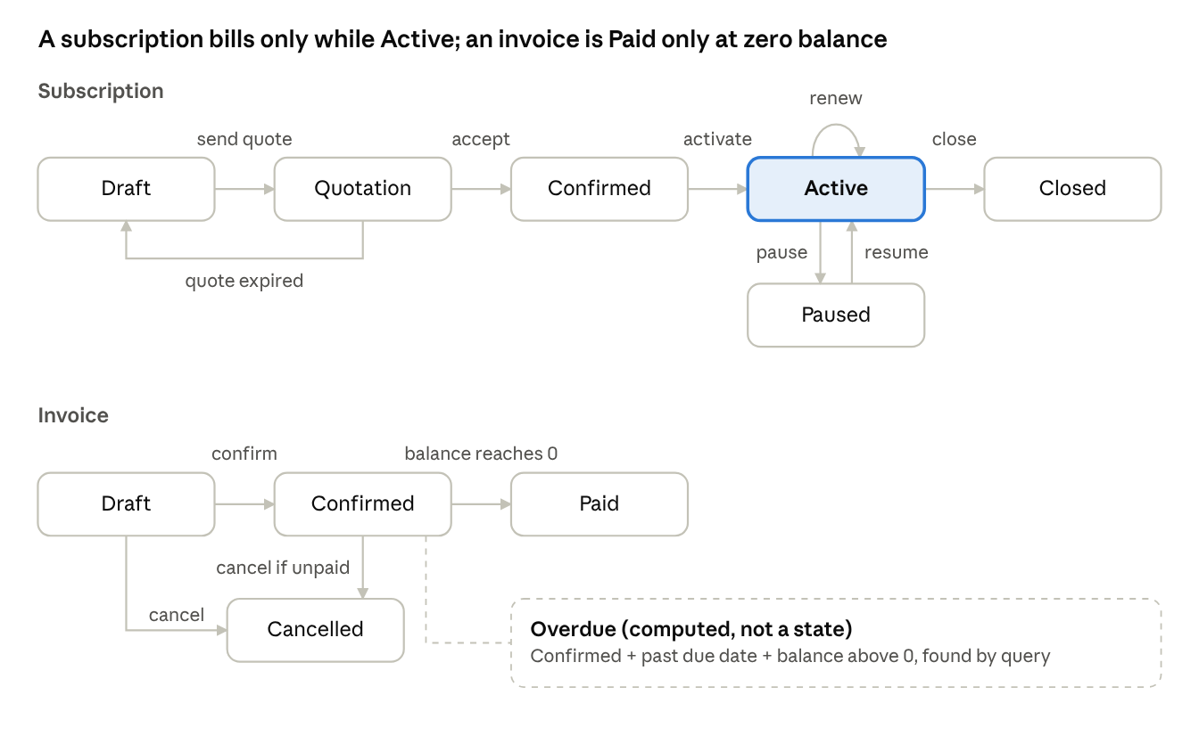
Subscription and invoice states · allowed transitions
Subscription transition guards
Transition | Allowed when
Draft → Quotation | Has a customer, a plan available today, and at least one line meeting minimum quantity
Quotation → Confirmed | Today ≤ quotation_valid_until
Quotation → Draft | Quotation expired (done automatically when someone opens it), so staff can revise and resend
Confirmed → Active | Today ≥ start_date; sets next_billing_date = start_date
Active → Paused → Active | Plan has pausable; paused subscriptions are skipped by billing
Active → Active (renew) | Plan has renewable; extends expiry_date by one term
Active → Closed | Automatically after expiry if plan has auto_close, or early by staff if plan has closable
Draft or Quotation → Closed | Staff cancels before confirmation
Invoice rules: only Draft invoices can be edited; payments only on Confirmed; status becomes Paid automatically when amount_paid = total; a Confirmed invoice can be cancelled only while nothing has been paid.

Core flows
These six flows are the whole product; the demo walks through them in this order.
1. Sign-up, login and password reset (accounts)
- Customer submits name, email, password, confirm password.
- Server checks: email not already used (case-insensitive), password passes the validator, passwords match.
- User is created with role customer, logged in, sent to the portal.
- Forgot password: Django's PasswordResetView emails a one-time link (printed to the terminal by the console backend). The link expires after use or after 1 day.
- Admin creates staff from a separate admin-only page; staff get role staff.
2. Product and plan setup (products)
- Admin creates a product with its tax rule, then adds variants (e.g. Brand = Odoo, +560).
- Admin creates a plan: price, billing period, minimum quantity, available dates, and the close/pause/renew flags.
- A plan outside its available dates cannot be picked for a new subscription.
3. Quotation to subscription (subscriptions)
- Staff picks a quotation template (or starts blank) and a customer. The template copies its plan, lines and payment terms into a new Draft subscription.
- Staff adjusts lines, then sends it as a quotation: status → Quotation, quotation_valid_until = today + validity_days.
- Customer accepts (or staff confirms on their behalf): status → Confirmed. An expired quotation cannot be confirmed.
- On the start date (or immediately if it is today or earlier), staff activates it: status → Active, next_billing_date = start_date.
4. Billing day (billing, see Billing engine)
- Staff clicks Run billing.
- Every Active subscription with next_billing_date ≤ today gets one Draft invoice per due period, with lines, discounts and tax filled in.
- Staff reviews, then confirms (Draft → Confirmed), sends (sent_at set) or prints.
5. Payment (billing)
- Staff records a payment against a Confirmed invoice: method, amount, date, note.
- amount_paid increases. When the balance reaches 0, status → Paid automatically.
- A partial payment leaves the invoice Confirmed with a smaller balance.
6. Month-end review (dashboard)
- Finance lead opens the dashboard and filters by date range or status.
- Sees active subscriptions, MRR, revenue collected, outstanding, overdue invoices and the overdue list, all from live queries.

Billing engine design
The billing run lives in billing/services.py as run_billing(today). It is triggered by a button (no background scheduler), is safe to click any number of times, and returns a summary such as "Created 37 invoices, skipped 3 already billed".
Algorithm
- Select subscriptions with status Active and next_billing_date ≤ today, using select_related('plan', 'customer') and prefetch_related('lines__product', 'lines__tax_rule').
- For each subscription, inside its own transaction.atomic() block:
  - While next_billing_date ≤ today and not past expiry_date: compute the period, build the invoice, save it, advance next_billing_date.
  - If the unique constraint on (subscription, period_start) fails with IntegrityError, that period is already billed: skip it and continue.
- After billing, subscriptions past expiry_date whose plan has auto_close move to Closed.
- Paused and Closed subscriptions are never selected.
One subscription failing rolls back only that subscription; the others still bill.
Billing periods and date maths
- Add a field Subscription.billed_cycles (integer, starts at 0).
- Period start = start_date + step × billed_cycles; period end = next period start − 1 day.
- Step: daily = relativedelta(days=1), weekly = relativedelta(weeks=1), monthly = relativedelta(months=1), yearly = relativedelta(years=1).
- Always count from start_date, never from the previous date. Chaining would drift: Jan 31 → Feb 28 → Mar 28. Counting from the start gives Jan 31 → Feb 28 → Mar 31.
- due_date = invoice_date + payment_terms_days.
Calculation order (per invoice)
- Line subtotal = quantity × unit_price (unit_price already includes the variant's extra price, copied when the line was created).
- Product discount per line = the single largest eligible discount linked to that line's product.
- Subscription discount = the single largest eligible discount linked to the subscription or to no product (applies to all), spread across lines in proportion to their remaining amount.
- Discounts can never make a line negative; they are capped at the line amount.
- Tax per line = (line subtotal − line discounts) × tax rate ÷ 100.
- Invoice totals = sums of the lines. Total = subtotal − discount_total + tax_total.
- Every amount is rounded to 0.01 with ROUND_HALF_UP, at line level, before summing.
Worked example: ₹1,000 × 5 = ₹5,000; discount ₹500; taxable ₹4,500; GST 18% = ₹810; total ₹5,310.
Discount eligibility
A discount applies only if all of these hold on the invoice date:
- is_active and start_date ≤ today ≤ end_date.
- usage_limit is empty or times_used < usage_limit.
- min_quantity is met (line quantity for a product discount, total quantity for a subscription discount).
- min_purchase is met (the relevant subtotal before discounts).
When applied, a DiscountUse row is created and times_used increases by 1 using F('times_used') + 1, inside the same transaction. Discounts are applied automatically by the run; staff never add them by hand to an invoice.
Invoice states
Draft → Confirmed → Paid, or Draft/Confirmed → Cancelled. Only Draft invoices can be edited. Cancelling a Confirmed invoice is allowed only while amount_paid = 0. Payments are recorded only on Confirmed invoices.
# billing/services.py — outline
def run_billing(today):
created = skipped = 0
due = (Subscription.objects
.filter(status=Subscription.ACTIVE, next_billing_date__lte=today)
.select_related('plan', 'customer')
.prefetch_related('lines__product', 'lines__tax_rule'))
for sub in due:
try:
with transaction.atomic():
while sub.next_billing_date <= today and not sub.is_past_expiry():
build_invoice(sub, today) # lines, discounts, tax, totals
sub.billed_cycles += 1
sub.next_billing_date = sub.period_start(sub.billed_cycles)
created += 1
sub.save()
except IntegrityError:
skipped += 1 # period already billed
close_expired_subscriptions(today)
return created, skipped

URL map
All pages are server-rendered. Every form posts back to its own URL; every action that changes state is a POST with a CSRF token, never a GET link. Each app mounts under its prefix with one include() line.
URL | Methods | Page or action | Who
/accounts/signup/ | GET, POST | Customer sign-up | Public
/accounts/login/, /accounts/logout/ | GET, POST | Login, logout | Public
/accounts/password-reset/… | GET, POST | Django's 4 built-in reset pages | Public
/accounts/staff/, /accounts/staff/new/ | GET, POST | List and create staff | Admin
/accounts/customers/, /accounts/customers/<id>/ | GET, POST | Customer list, detail, edit | Admin, Staff
/products/, /products/new/, /products/<id>/edit/ | GET, POST | Products with inline variants | Admin (Staff view)
/products/plans/, /products/plans/new/, /products/plans/<id>/edit/ | GET, POST | Plans | Admin (Staff view)
/subscriptions/ | GET | List with status and customer filters, paginated | Admin, Staff
/subscriptions/new/?template=<id> | GET, POST | Create from template or blank | Admin, Staff
/subscriptions/<id>/ | GET | Detail with lines, invoices, status history | Admin, Staff
/subscriptions/<id>/<action>/ | POST | send-quote, confirm, activate, pause, resume, renew, close | Admin, Staff
/subscriptions/templates/… | GET, POST | Quotation templates list, create, edit | Admin
/billing/run/ | POST | Run billing, shows summary | Admin, Staff
/billing/invoices/, /billing/invoices/<id>/ | GET | Invoice list (filters: status, overdue, date) and detail | Admin, Staff
/billing/invoices/<id>/<action>/ | POST | confirm, cancel, send | Admin, Staff
/billing/invoices/<id>/print/ | GET | Print-friendly invoice | Admin, Staff
/billing/invoices/<id>/payments/new/ | GET, POST | Record a payment | Admin, Staff
/billing/discounts/…, /billing/taxes/… | GET, POST | Discount rules and tax rules | Admin
/dashboard/ | GET | Finance dashboard with filters | Admin, Staff
/portal/ | GET | My subscriptions | Customer
/portal/invoices/, /portal/invoices/<id>/ | GET | My invoices, detail, print | Customer (own only)
/portal/subscriptions/<id>/accept/ | POST | Accept a quotation | Customer (own only)
No JSON API is planned. If a page later needs live updates without reload, add a small JSON view in that app; the URL list above stays the contract.

Validation rules
Every rule below is enforced in the Django form (clean() methods) and, where marked, also by a database constraint. HTML attributes like required and min are added for convenience only. Errors appear next to the field in plain language, and the form keeps what the user typed.
Form | Field | Rule | Error message
Sign-up | Email | Valid format; unique ignoring case (DB unique) | "An account with this email already exists."
Sign-up | Password | More than 8 characters, at least one uppercase, one lowercase, one special character | "Password needs 9+ characters with upper, lower and a special character."
Sign-up | Confirm password | Matches password | "Passwords don't match."
Sign-up, customer | Phone | Optional; digits, spaces, +, 7–15 digits | "Enter a valid phone number."
Product | Sales price, cost price | ≥ 0, max 2 decimals | "Enter an amount of 0 or more."
Variant | Attribute + value | Unique per product (DB unique) | "This variant already exists."
Plan | Price | > 0 | "Price must be more than 0."
Plan | Minimum quantity | Whole number ≥ 1 | "Minimum quantity must be at least 1."
Plan | End date | After start date, if given | "End date must be after start date."
Quotation template | Validity days | Whole number 1–365 | "Validity must be 1 to 365 days."
Subscription | Plan | Available today (within plan dates) | "This plan isn't available on that date."
Subscription | Lines | At least one line | "Add at least one product line."
Subscription line | Quantity | ≥ plan minimum quantity | "Minimum quantity for this plan is N."
Subscription | Expiry date | After start date, if given | "Expiry date must be after start date."
Subscription action | Status change | Allowed by the state machine and plan flags | "Can't pause: this plan doesn't allow pausing."
Discount | Value | > 0; ≤ 100 when percent | "Percentage can't be more than 100."
Discount | Dates | End date after start date | "End date must be after start date."
Discount | Usage limit | Empty or whole number ≥ 1 | "Usage limit must be at least 1."
Tax rule | Rate | 0–100 | "Tax rate must be between 0 and 100."
Payment | Amount | > 0 and ≤ invoice balance | "Amount can't exceed the balance of ₹X."
Payment | Date | Not in the future | "Payment date can't be in the future."
Payment | Invoice | Status is Confirmed | "Payments can only be recorded on confirmed invoices."
The password rule lives in one place, accounts/validators.py, registered in AUTH_PASSWORD_VALIDATORS, so sign-up, staff creation and password reset all use it.
# accounts/validators.py
import re
from django.core.exceptions import ValidationError
class StrongPasswordValidator:
def validate(self, password, user=None):
if (len(password) <= 8
or not re.search(r'[A-Z]', password)
or not re.search(r'[a-z]', password)
or not re.search(r'[^A-Za-z0-9]', password)):
raise ValidationError(
'Password needs 9+ characters with upper, lower and a special character.')
def get_help_text(self):
return 'More than 8 characters, with uppercase, lowercase and a special character.'

Reporting and performance
Every dashboard number is one aggregate query on live data, never a hard-coded value or a Python loop over rows. Filters (date range, customer, plan) narrow the same queries.
Metric definitions
Metric | Definition | Query
Active subscriptions | Subscriptions with status Active | Subscription.objects.filter(status='active').count()
MRR | Monthly value of all Active subscriptions; weekly × 52 ÷ 12, yearly ÷ 12, daily × 365 ÷ 12 | Sum over active subscription lines, grouped by billing period, then converted
Revenue collected | Sum of payments in the date range | Payment.objects.filter(payment_date__range=…).aggregate(Sum('amount'))
Outstanding | Sum of balances on Confirmed invoices | Sum(F('total') - F('amount_paid')) on status Confirmed
Overdue | Confirmed invoices past due date with a balance; count and amount | filter status='confirmed', due_date__lt=today, total__gt=F('amount_paid')
Invoices by status | Count per status for a chart | values('status').annotate(Count('id'))
Revenue by month | Payments grouped by month, last 6 months, for the line chart | TruncMonth('payment_date') + Sum('amount')
MRR (what the business is set to earn each month) and revenue collected (money actually received) are different numbers. The dashboard shows both, labelled.
Keeping every page under 2 seconds with thousands of records
- Indexes: Subscription (status, next_billing_date) and (customer); Invoice (status, due_date) and (subscription, period_start); Payment (payment_date). Declared in each model's Meta.indexes.
- No N+1 queries: list views use select_related for foreign keys and prefetch_related for lines. A list page should run under 10 queries no matter how many rows.
- Pagination: 25 rows per page on every list, using Django's Paginator.
- Aggregates in the database: Sum, Count, F() expressions; never load all rows into Python to add them up.
- Proof: python manage.py seed_data --subscriptions 5000 creates realistic data (customers, plans, subscriptions across all states, a year of invoices and payments). Check timing with Django Debug Toolbar or the browser's network tab, and show the number in the demo.

Project structure, Git workflow and environment
One repository, one Django project named config, six apps at the top level.
brightloop/
├── config/ # M2: settings.py, urls.py, wsgi.py
├── accounts/ # M2: User, validators.py, decorators.py, auth views
├── products/ # M2: Product, ProductVariant, Plan
├── subscriptions/ # M1: Subscription, lines, templates, services.py
├── billing/ # M3: TaxRule, Discount, Invoice, Payment, services.py
├── dashboard/ # M4: metrics views, management/commands/seed_data.py
├── portal/ # M4: customer pages
├── templates/
│ ├── base.html # M4: layout, navbar by role, messages
│ └── registration/ # M2: login and password reset templates
├── static/ # M4: css/app.css, js/charts.js
├── requirements.txt # django, python-dateutil
├── .gitignore # db.sqlite3, __pycache__/, .venv/, .env
├── README.md # M1
└── manage.py
Local setup (each member, once)
git clone <repo-url> && cd brightloop
python -m venv .venv && source .venv/bin/activate # Windows: .venv\Scripts\activate
pip install -r requirements.txt
python manage.py migrate
python manage.py seed_data
python manage.py runserver
Settings that matter
- AUTH_USER_MODEL = 'accounts.User', set before the first migration. Changing it later means deleting the database and all migrations.
- EMAIL_BACKEND = 'django.core.mail.backends.console.EmailBackend' so reset links print in the terminal, offline.
- TIME_ZONE = 'Asia/Kolkata', USE_TZ = True; dates in billing use timezone.localdate().
- LOGIN_REDIRECT_URL points to a small view that sends each role to its home page.
Hourly push to main
- Push window is :45 to :55 every hour; all four members push.
- Before pushing: git pull --rebase origin main, then python manage.py migrate and runserver. Push only if pages load.
- Touch only your own app folders; shared files go through their owner (see Django apps and ownership).
- Only an app's owner runs makemigrations for that app. On a migration conflict: delete your unpushed migration file, pull, run makemigrations again.
- Commit messages start with the app name: [billing] add idempotent run_billing.
- At :55, M1 pulls main, runs the server and clicks through 3 pages. A break is fixed by whoever caused it before anything else.
- Never commit db.sqlite3. Shared data comes from seed_data, which everyone can re-run after deleting their database.

Out of scope and known limitations
These are deliberate choices for an 8-hour build. Say them out loud in the demo; judges respect a clear boundary more than a hidden gap.
- No real payment gateway. Payments are recorded by staff, as in the problem statement. Razorpay or Stripe could plug into the Payment model later.
- No real email delivery. Reset links and "sent" invoices go to the console backend. Switching to SMTP is a settings change.
- No background scheduler. Billing runs from a button. In production, a daily cron job would call the same run_billing().
- No proration. Mid-period quantity changes take effect from the next billing period.
- Single currency (₹) and simple tax rules. One tax rate per product line; no inter-state GST split.
- SQLite. Fine for a demo with thousands of rows and offline use; switch to PostgreSQL for concurrent production use by changing DATABASES.
- No multi-company support. Built for Brightloop only, as the problem statement describes.
- Open question: confirm with the organisers whether variants should change the subscription line price automatically or only show as a separate line. This design adds the variant's extra price to the line's unit price.

